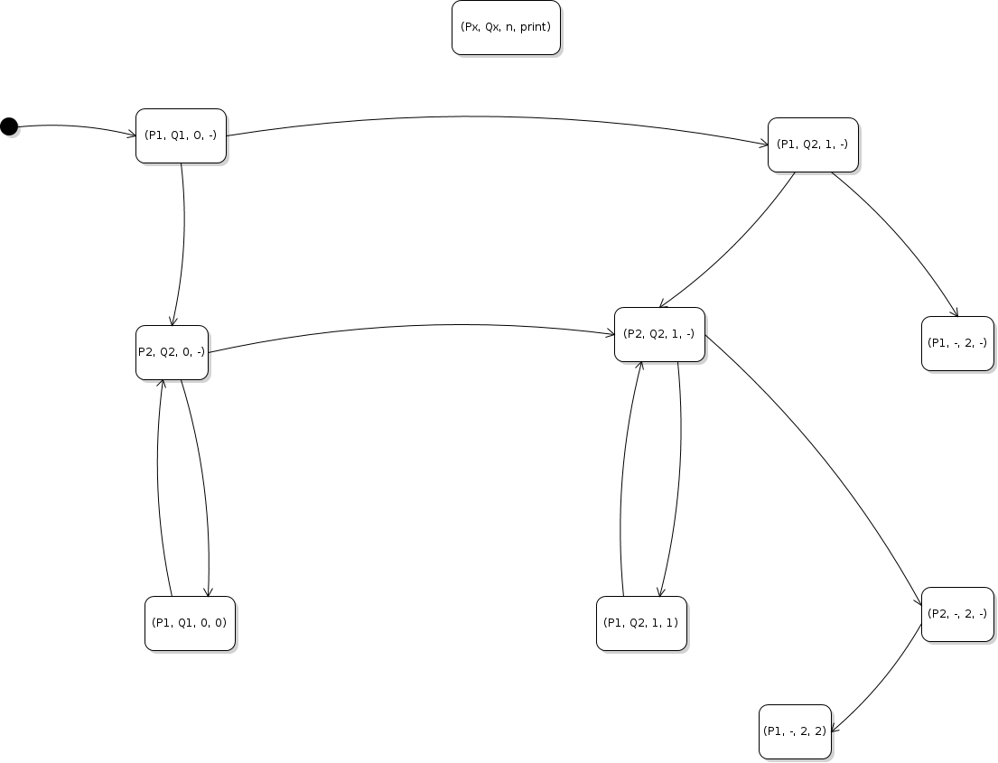
2. 012: → (P1, Q1, 0, -) → (P2, Q1, 0, -) → (P1, Q1, 0, 0) → (P2, Q1, 0, -) → (P2, Q2, 1, -) → (P1, Q2, 1, 1) → (P2, Q2, 1, -) → (P2, -, 2, -) → (P1, -, 2, 2)
002: → (P1, Q1, 0, -) → (P2, Q1, 0, -) → (P1, Q1, 0, 0) → (P2, Q1, 0, -) → (P1, Q1, 0, 0) → (P2, Q1, 0, -) → (P2, Q2, 1, -) → (P2, -, 2, -) → (P1, -, 2, 2)
02: → (P1, Q1, 0, -) → (P2, Q1, 0, -) → (P1, Q1, 0, 0) → (P2, Q1, 01, -) → (P2, Q2, 1, -) → (P2, -, 2, -) → (P1, -, 2, 2)
3. It does not necessarily have to appear. It is possible for both lines of Q to be executed before the loop in P checks the value of n, meaning n (2) will not be printed.
4. 2 can only appear in the input once, because after it is printed once, the loop will check and see that n = 2.
5. 1 can appear an infinite number of times, if the first line of Q executes and then the entirety of P keeps executing consecutively.
6. 0 can appear an infinite number of times, if no lines of Q execute and the entirety of P keeps executing consecutively.
7. The shortest length is 0. If both lines of Q are executed before the first time P checks the value of n, then nothing will be printed at all.

